**Homework3 for General physics Answers**

**1.** Hecht’s 10.2 ( Deriving the interference term of Multi-slits by phasor method)

Answer:

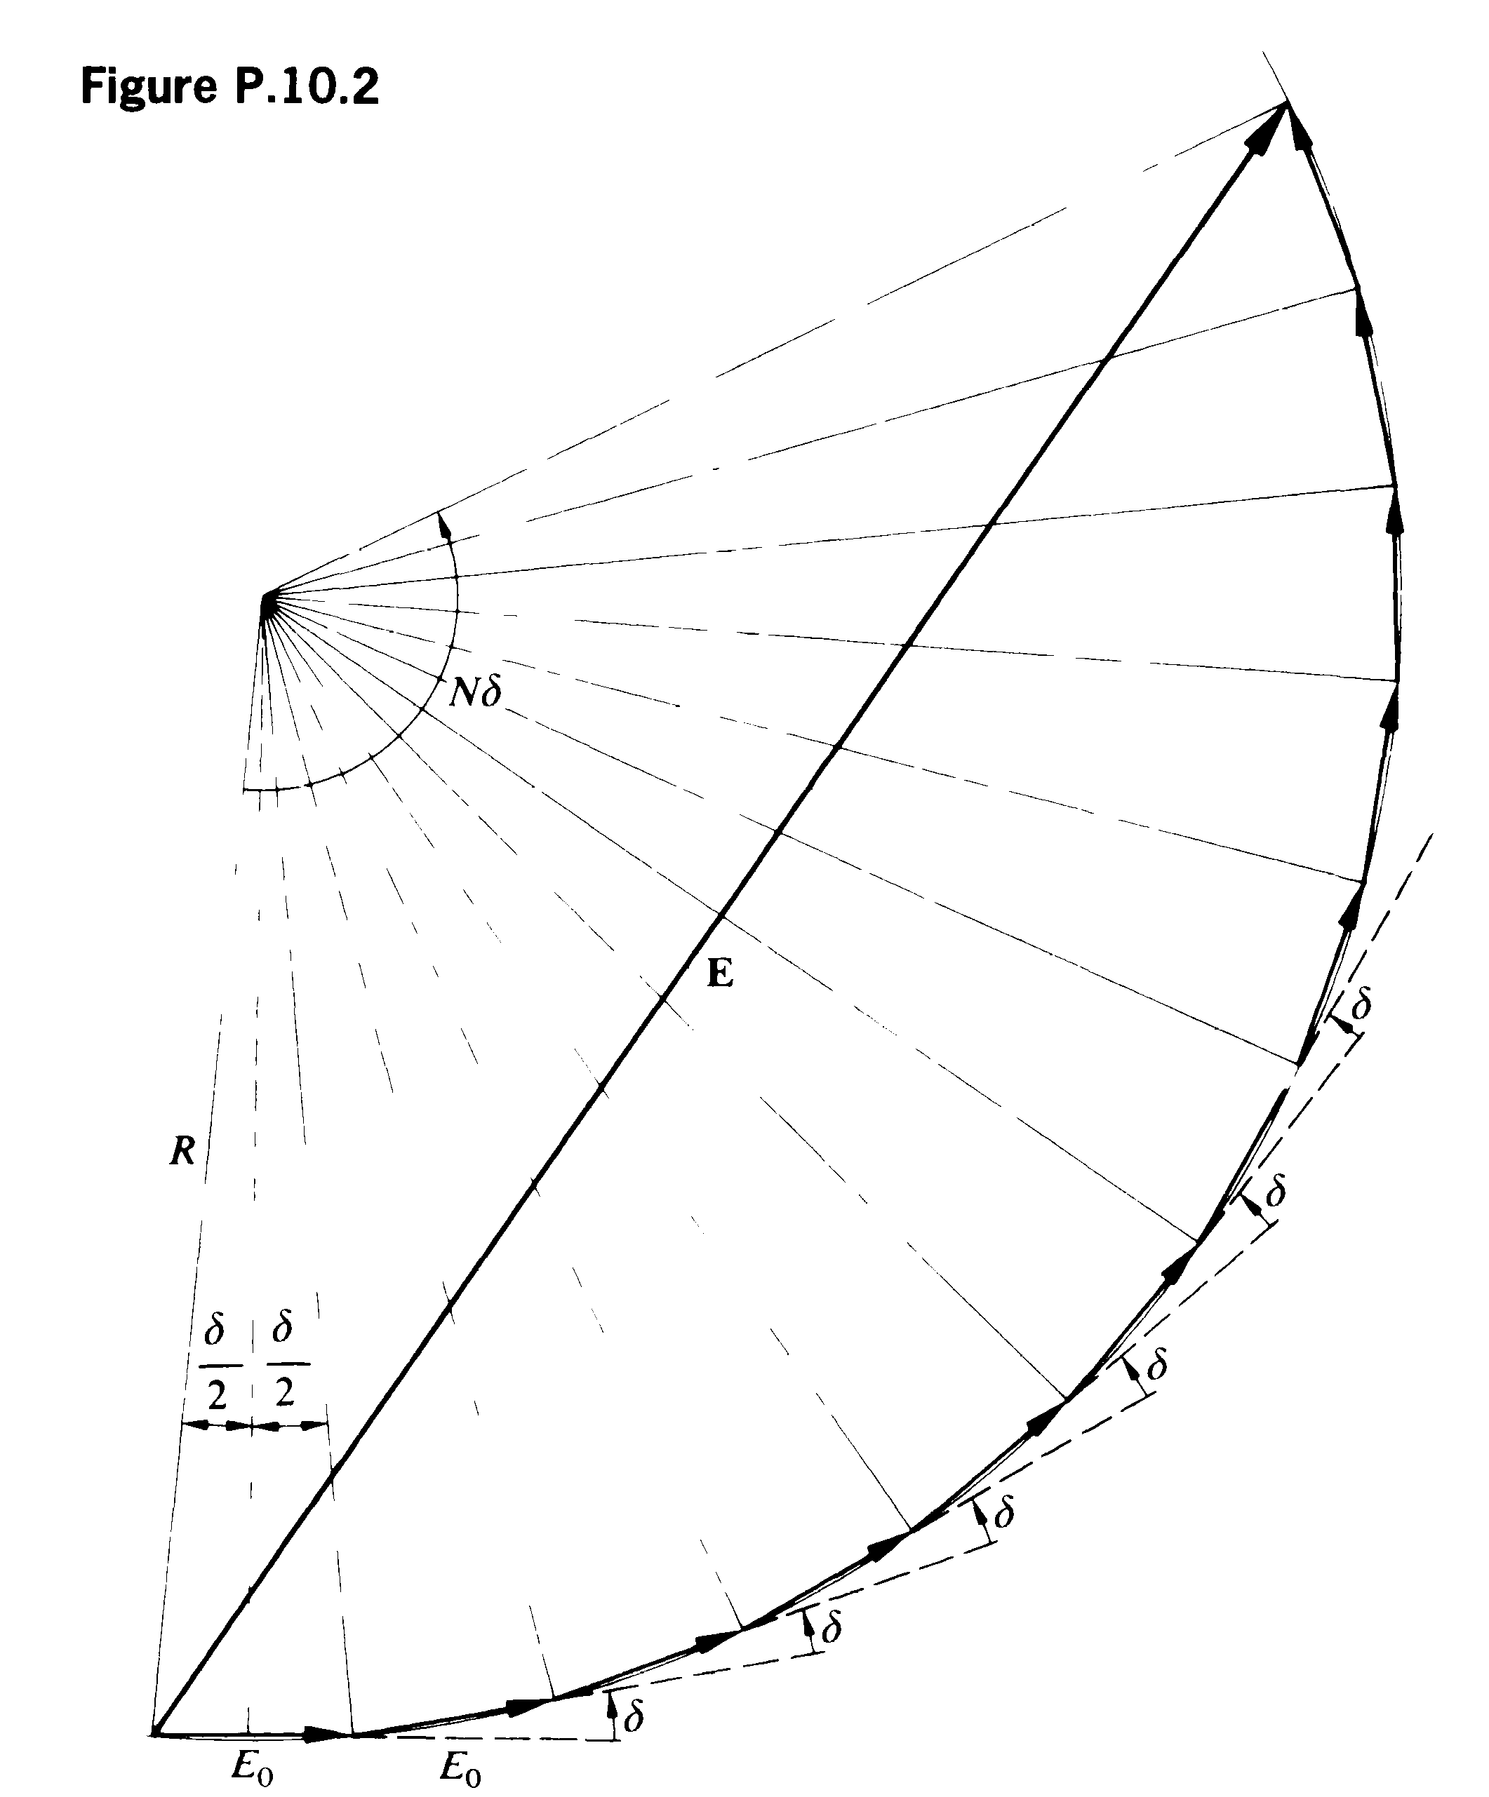

The total field strength is E, which is summation of each components with size E0 and phase difference between adjacent pair is , the summation of all these using phasor method is shown in the figure:

And when there are many components, the phasor diagram is approaching a circle with radius R:





This is the result asked in the problem.

In multi-slits F-diffraction  (single slit contribution), , we get the formula for N identical multi-slits results.

1. **A 3-slit grating consists of three parallel slits on a plane, each slit has width of a, and separated by d (center to center). Place a transparent plate to cover the middle slit so that it alters the phase of light passing through it by π. A plane wave of wavelength λ shines the grating plane perpendicularly; observe the Fraunhofer diffraction pattern on the back focal-plane of a lens.**
2. **What is the irradiance distribution of the diffraction pattern?**

Answer:

Without the transparent plate, the diffraction amplitude can be obtained easily by Fourier transformation, i.e.

$$\tilde{U}\left(θ\right)∝sinc(\frac{kasinθ}{2})[1+e^{i∙kdsinθ}+e^{i∙2kdsinθ}]$$

Where each term represents the contribution of each slit, respectively.

The introduction of a transparent plate is to multiply the second term by $e^{iπ}$.

Therefore, the final diffraction field:

$$\tilde{U}\left(θ\right)∝sinc(\frac{kasinθ}{2})[1-e^{i∙kdsinθ}+e^{i∙2kdsinθ}]$$

$$I_{θ}=I_{0}{sinc}^{2}\left(\frac{kasinθ}{2}\right){[2cos⁡(kdsinθ)-1]}^{2}$$

The second component represents a fast variation while the sinc function modulates the amplitude.

1. **What is the condition for the principle maxima (due to interference among slits), what is the condition for zero-irradiance?**

Answer:

Principle maxima:

$$\cos\left(kdsinθ\right)=-1$$

$$sinθ=\left(m+\frac{1}{2}\right)\frac{λ}{d}, m is an integer.$$

Zero-irradiance:

$$\cos\left(kdsinθ\right)=\frac{1}{2}$$

$$sinθ=\left(n±\frac{1}{6}\right)\frac{λ}{d}, n is an integer.$$

$There is another possible case where \frac{kasinθ}{2}=nπ$, zero irradiance due to single element.

3. （Zhao’s problem 6 on pg. 17 of Vol. 2）



For a diffraction screen with two slits with different width, slit has width a, slit 2 has width 2a, their center are separated by d=3a; what is the Fraunhoffer diffraction intensity pattern?

Answer: There are a few ways to work it out:

Method 1: treat the slits as they are presented, the contribution by slit 1 is U1, and by slit 2 is U2, notice their form will be different due to size difference ( a and 2a) and a phase difference between them:









I0 is the maximum intensity by slit 1 only;  The first two terms are contribution from single slits 1 and 2 respectively, and last is their interference.

Method 2: (For the following methods I would outline the thinking and skip calculation details)

Direct integration of the diffraction screen: (choose x=0 at center of the first slit)

 is the OPL from center (origin of diffraction screen) to point on observing screen,

OPL of other points on diffraction screen is (for Fraunhoffer):





I skipped the calculation and it will give same results as method 1.

Method 3:

We can treat two slits with unequal width as 3 slits with same width a, just treat slit 2 as if there are two slits with width a, these slits are separated from slit 1 by  respectively:

Now the single element contribution to field is same for these 3 slits and difference is lying in their phase factor:





4. Hecht’s 10.33

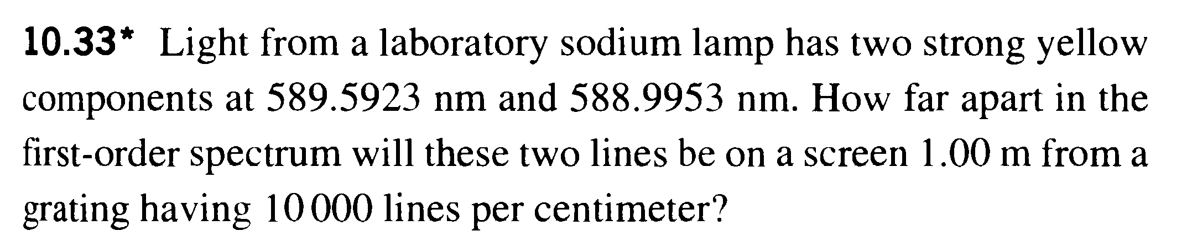

Answer:



In the problem m=1, d=,

 ( I took the average of the two wavelengths, if taken any of it, the result would be OK too)









5. Hecht’s 10.38

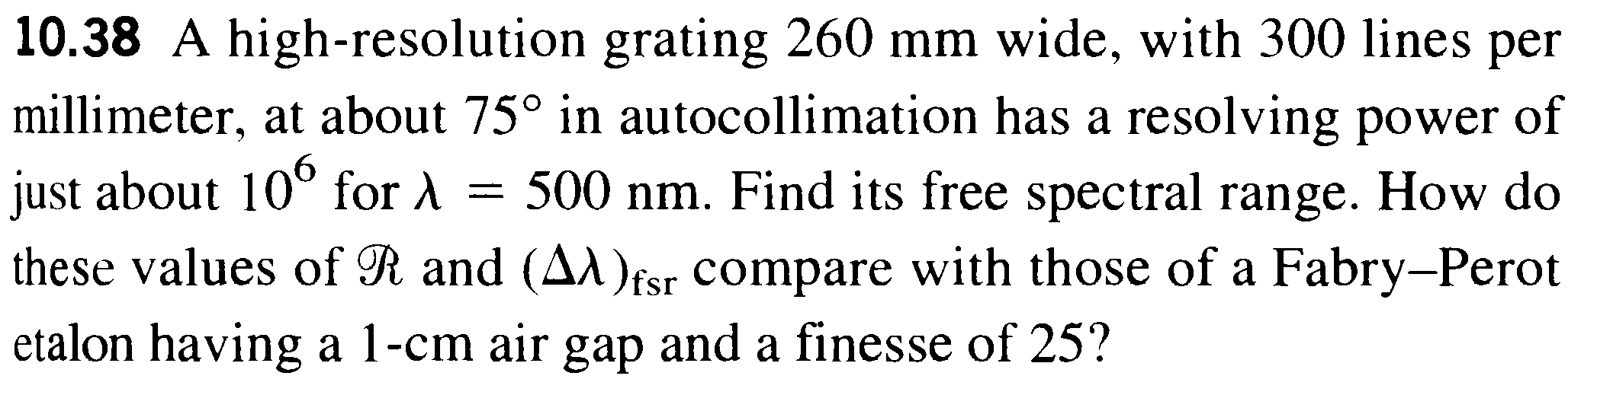

Answer:

Autocollimation is shown in Hecht’s pg. 480:

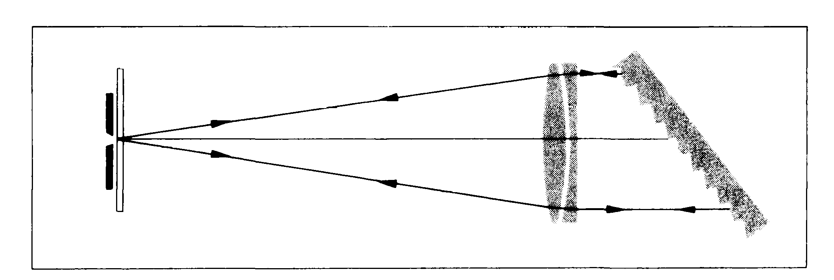

We need m (the order of principal maxima) to analyze free spectra range. M can be determined from:

It is a reflection type grating and grating equation is:

 (Hecht use a instead of d, and he use – sign but with +- angle)

+ when diffraction angle and incident are on the same side of base normal; - if they are on different sides.

Here according to his book, diffraction angle and incident are on the same side of base normal so we use + in above formula.





For blazed reflection type the maximum intensity (considering the modulation of single element diffraction) is when  (where the useless 0th principle maximum is at  which is on the other side of base normal)

 (13th order principal maximum for 500nm will appear at an angle a little larger than 75 degree)

As a check, R=mN, R is resolution, N is total line number=78000, indeed R is 106.

Here in the question, it is not clear whether the 500 nm is the red end (longest wavelength) or blue-end (shortest wavelength) of the spectrum, so I shall analyze both. If 500nm is red-end:

14th order of short wavelength may overlap with 13th of 500, and that wavelength is:



So  (you can also get this by 500nm/14)

If the 500 nm is blue-end, the 12th order of longer wavelength may overlap with it:



 in this case. (or 500nm/12)

(If you directly take Hecht’s formula, it is corresponding to this 500nm as blue-end result)

If we use provided F-P to analyze the 500 nm,



 (This F-P has pretty low finesse)



, with 



(here since m is big, if you take 500nm as red or blue end, will practically give same result , which is 500nm/m, same as I calculated above starting from free-spectral range in frequency)

F-P usually has much smaller free-spectral range but with higher finesse, has better resolution.

1. **(Hecht’s 10.40)Imagine an opaque screen containing 30 randomly located circular holes. The light source is such that every aperture is coherently illuminated by its own plane wave. Each wave in turn is completely incoherent with respect to all the others. Describe the resulting far-field diffraction pattern.**

Answer:

A diffraction pattern by a circular hole is given in the book. Since each curve in one hole is completely incoherent with respect to all the others, the final pattern is the summation of irradiance by the 30 holes.

1. **Basically a reflected blazed grating for Fraunhofer diffraction with input and output focusing mirrors. The blazed grating spectrometer with the grating of 1000 lines/mm and the grating is 100mm-long, with blaze angle θb, the focal length of the mirror is 1 meter.**

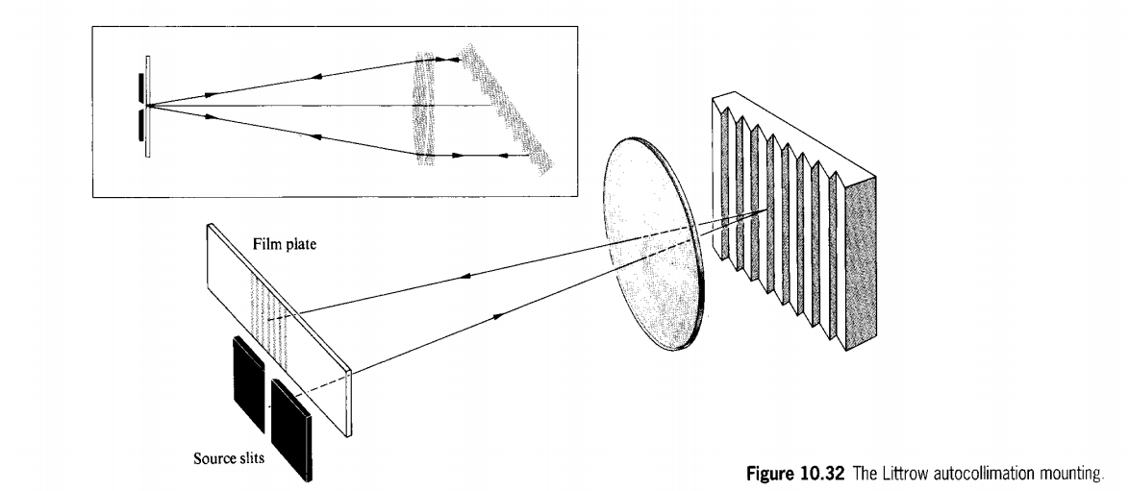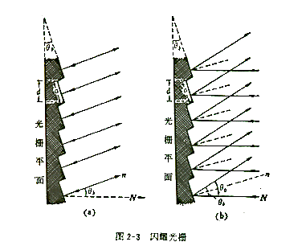

**The incoming light is along the direction of the facet’s normal.**

1. **When use the first-order of such grating, If the maximum dispersible wavelength will be 1000nm (that is the limiting case for a flat reflection grating, or θb=0), then what is** **the minimum wavelength in the first order without introducing confusion due to mixing of order, and what is the free spectral range? For the second-order of this grating working for the maximum wavelength of 500nm, answer the same questions for the second order.**

Answer:

$$2λ_{min,1}=λ_{max,1}=dsinθ_{m,1}$$

The minimum wavelength in the first order without introducing confusion due to mixing of order:

$$λ_{min,1}=\frac{λ_{max,1}}{2}=\frac{1000nm}{2}=500nm$$

$$⟹Δλ_{free}=500nm$$

$$3λ_{min,2}=2λ_{max,2}=dsinθ_{m,2}$$

$$⟹λ_{min,2}=333nm$$

$$⟹Δλ_{free}=167nm$$

1. **If we want the center wavelength (middle-point) in the free spectral range has the highest irradiance modulation due to diffraction by single element, what is the blazed angle of the grating then? (estimate for the 1st order)**

Answer:

$$λ=750nm$$

$$2dsinθ_{b}=λ$$

$$⟹θ_{b}=arcsin\frac{λ}{2d}=arcsin\frac{750×{10}^{-9}}{2×{10}^{-3}×{10}^{-3}}=22°$$

1. **At such blazed angle in (2), what are the angles corresponding to the maximum and minimum wavelengths for first order in question (1) (the angles are measured with respect to ‘N’, the normal to the base of the grating, see the right figure.)**

Answer:

For the 1st order pattern:

$$d\left(sinθ+sinθ_{b}\right)=+(or-)λ$$

For $λ_{max}=1000nm$

$$θ_{max}=38.7°$$

The minus lambda would correspond to -1 order and is not considered here.

For $λ_{min}=500nm$

$$θ_{min}=7.18°; θ_{min}=-61.0° abandoned.$$

“ $7.18°$ is the one we are looking for, the other one belongs to -1 order and can be discarded. (We only consider the diffraction angles close to the blaze angle).”

1. **Due to irradiance modulation by single element diffraction, the irradiance of the maximum and minimum wavelengths will be less than that of the center wavelength, what are the ratios of irradiance between the maximum and minimum wavelengths with respect to that of the center wavelength.**

Answer:

The ratio is given by the sinc function:

$$\frac{I_{max}}{I_{0}}={sinc}^{2}\left[\frac{kasin(θ_{max}-θ_{b})}{2}\right]={sinc}^{2}\left[\frac{π\frac{d}{cosθ_{b}}sin(θ_{max}-θ_{b})}{ λ_{max}}\right]={sinc}^{2}\left[\frac{π\frac{{10}^{-6}}{cos22°}sin(38.7°-22°)}{{10}^{-6}}\right]=0.721$$

$$\frac{I_{min}}{I_{0}}={sinc}^{2}\left[\frac{kasin(θ_{min}-θ_{b})}{2}\right]={sinc}^{2}\left[\frac{π\frac{d}{cosθ_{b}}sin(θ_{min}-θ_{b})}{λ_{min}}\right]={sinc}^{2}\left[\frac{π\frac{{10}^{-6}}{cos22°}sin(7.18°-22°)}{0.5{×10}^{-6}}\right]=0.324$$

1. **For light at about 600 nm region, what is the minimum resolvable wavelength, and for two wavelengths in this region separated by minimum resolvable wavelength, what is their linear separation at the outlet slit S2. (Fig.2-5, take focal length of the mirror 1m)**

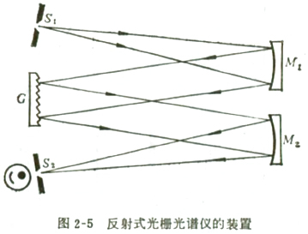

Answer：



$$δλ_{m}=\frac{λ}{mN}=\frac{600nm}{1×100×1000}=6{×10}^{-3}nm$$

$$θ_{m}=\arcsin\left(\frac{λ}{d}-sinθ_{b}\right)=\arcsin\left(\frac{600{×10}^{-9}}{{10}^{-6}}-sin22°\right)=13°$$

$Δl=fΔθ=f\frac{λ}{Ndcosθ_{m}}=\frac{fmδλ_{m}}{dcosθ_{m}}=6.16{×10}^{-6}m$ =6.16um

1. **To use the full power of chromatic resolution of the spectrometer, the outlet slit should be about the value you estimated in (5). However, in real experiment, people usually use wider slit to collect more light. If the outlet slit is taken as 1mm, then what is the spread of wavelength δλ that can pass the slit and collected by detector?**

Answer：

$Δλ=\frac{Δl∙dcosθ_{m}}{f}=0.974nm$, or use 